OudhTrade
Functional Requirements (FRS)
Module 1 — Platform Foundation · M01-2
Document details
Company | MRIDA INFRA AND PLANTATIONS LLP
Product | OudhTrade — oudhtrade.com
Document | M01-2 Functional Requirements (FRS)
Module | M01 Platform Foundation (release R1)
Readers | Developers, QA, product owner
Related documents | PRD (PRD-FND, PRD-CMP) · HLD · other M01 documents
Owner | Product owner
Decision owner | T. Satish Reddy, CEO & Founder
Status | Draft for review — 24 September 2026
Classification | Confidential — for partners and the OudhTrade team

Contents
1. How to read this FRS 2
2. Environments & Releases (ENV) 2
3. File & Media Service (FIL) 3
3.1 Photos 3
3.2 Documents 4
3.3 Video 4
3.4 All files 4
3.5 Photo location and photo safety 5
4. Units & Conversion (UNT) 6
5. Languages & Formats (LOC) 7
6. Page Addresses & SEO (URL) 8
7. Audit Log (AUD) 9
8. Configuration & Feature Switches (CFG) 10
9. Events, Jobs & Scheduler (EVT) 11
10. Data Retention & Legal Hold (RET) 12
11. Cookie Consent (CKE) 13
12. API Conventions & Errors (API) 13
13. Monitoring (OBS) 14
14. Country & Currency Reference (CTY) 15
15. Rate Limits (RTL) 15
16. Edge & Application Security (SEC) 16
17. AI Gateway (AIG) 17

1. How to read this FRS
Each requirement has an ID (M01-FR-<area>-nnn), a priority (Must / Should / Could) and a release. Numbers marked “configurable” are defaults Admin can change without code. Every requirement traces to the PRD (see M01-1 Section 8) and has test cases in M01-7.

2. Environments & Releases (ENV)
ID | Requirement | Priority | Release
M01-FR-ENV-001 | Three environments — development, staging, production — each in its own AWS account with separate keys and passwords. | Must | R1
M01-FR-ENV-002 | All infrastructure is created from code (Terraform or AWS CDK); no manual changes in production. | Must | R1
M01-FR-ENV-003 | Build pipeline runs automated tests and security scans on every change; database changes run as a separate controlled step; production releases need approval. | Must | R1
M01-FR-ENV-004 | Feature switches turn features on per release (R1, R2, R3) and per environment without a new deployment; switch changes are logged. | Must | R1
M01-FR-ENV-005 | Staging and development use only made-up data and the demo data set. Production data is never copied to them, not even anonymised; no tool or pipeline step exists to do so. | Must | R1
M01-FR-ENV-006 | Test sites are password-protected, blocked from search engines, send messages only to a test inbox and use the payment gateway’s test mode. | Must | R1
M01-FR-ENV-007 | A demo data set covers all 6 categories, all roles and typical listings, and can be reloaded on staging at any time. | Must | R1
M01-FR-ENV-008 | Configuration can be exported from staging and imported into production (with approval). | Must | R1
M01-FR-ENV-009 | Backups: the database is backed up continuously with point-in-time restore for 35 days (starting value, configurable); daily snapshots are kept; file storage (S3) is copied to Hyderabad by cross-region replication. | Must | R1
M01-FR-ENV-010 | Warm standby and DR plan: the database runs in several zones in Mumbai. A copy in Hyderabad is kept a few seconds behind, with no user traffic; if the Mumbai region fails it is promoted and the site pointed there. The Keycloak database has a cross-region replica in Hyderabad; search (Typesense) is rebuilt from PostgreSQL; Redis starts empty; containers are rebuilt from infrastructure code. Data loss (RPO): 5 minutes within Mumbai; target ≤ 1 minute if the region is lost. Restore time (RTO): 24 hours in R1, 8 hours from R2. A written DR plan is owned by the tech lead. | Must | R1
M01-FR-ENV-011 | Drills: every quarter a production backup (the Hyderabad copy) is restored into an isolated AWS account and the RPO and RTO are timed; every year the Hyderabad standby is promoted in a failover test. Results are reported to the founder and tech lead. | Must | R1
M01-FR-ENV-012 | White-label ready: no brand name, colours or logos are hard-coded; the brand comes from design tokens and configuration. | Must | R1

3. File & Media Service (FIL)

3.1 Photos
ID | Requirement | Priority | Release
M01-FR-FIL-001 | Accepted photo formats: JPG, PNG, WEBP, HEIC; other formats are rejected with a clear message. | Must | R1
M01-FR-FIL-002 | Maximum upload size 15 MB per photo (configurable); checked in the browser before upload and again on the server. | Must | R1
M01-FR-FIL-003 | Each photo is converted to web formats and resized to standard sizes (thumbnail, medium, large); the original is kept privately. | Must | R1
M01-FR-FIL-004 | Location (GPS) and device data are always removed from every public photo variant. | Must | R1
M01-FR-FIL-005 | A listing has 1–10 photos (configurable); the first is the cover; order can be changed by drag and drop. | Must | R1
M01-FR-FIL-006 | Quality check warns (does not block) when a photo is smaller than 800 px on its short side or looks blurred. | Should | R1
M01-FR-FIL-007 | Seller can switch on an OudhTrade watermark for their photos (off by default); the watermark is applied to public variants only. | Should | R1

3.2 Documents
ID | Requirement | Priority | Release
M01-FR-FIL-008 | Accepted document formats (verification documents and other documents): PDF, JPG, PNG, HEIC / HEIF and WEBP; maximum 10 MB per file (configurable). HEIC / HEIF and WEBP files are converted on the server so reviewers can open them; the original is kept privately. | Must | R1
M01-FR-FIL-009 | Documents are stored privately and opened only through short-lived signed links; every opening is written to the audit log. | Must | R1
M01-FR-FIL-010 | Documents are never shown on public pages, never cached by the CDN and never indexed by search engines. | Must | R1

3.3 Video
ID | Requirement | Priority | Release
M01-FR-FIL-011 | One video per listing; formats MP4 or MOV; maximum 100 MB and 60 seconds (both configurable). | Must | R1
M01-FR-FIL-012 | Videos longer than 60 seconds are rejected with the message “Video must be 60 seconds or shorter”. | Must | R1
M01-FR-FIL-013 | Each video is converted to a 720p web version and a cover image is created automatically; location data is removed. | Must | R1
M01-FR-FIL-014 | Before upload, the system checks the seller’s video allowance (from Module 11 plan settings; default 2 listings for free plans and farmers). | Must | R1
M01-FR-FIL-015 | A processed video is not shown publicly until a moderator approves it (Module 12); the seller sees its status: processing, in review, live, rejected with reason. | Must | R1
M01-FR-FIL-016 | Videos play muted by default with a sound button; they are delivered through the CDN and load only when played. | Must | R1
M01-FR-FIL-017 | Only verified sellers and verified farmers can upload video. | Must | R1

3.4 All files
ID | Requirement | Priority | Release
M01-FR-FIL-018 | Every file is uploaded to a quarantine area and scanned for malware; it is not used anywhere until the scan passes. Infected files are deleted and the event is logged. | Must | R1
M01-FR-FIL-019 | Files belong to an owner and a purpose (listing photo, verification document, chat attachment…); access follows the purpose’s rules. | Must | R1
M01-FR-FIL-020 | Unused uploads (never attached) are deleted after 7 days (configurable). | Must | R1
M01-FR-FIL-021 | Upload progress, retry on network failure and resume for large files (video) are supported. | Must | R1

3.5 Photo location and photo safety
ID | Requirement | Priority | Release
M01-FR-FIL-022 | The private original photo keeps its location data. Only staff with the verification permission (M03) can see it, for origin checks (M03 / M06); every view is written to the audit log. At upload the seller sees: “Location is never shown publicly. OudhTrade staff may use it to check origin.” | Must | R1
M01-FR-FIL-023 | Every photo and every video cover image is checked for written text and QR codes. If a phone number, email address, UPI ID, web address or QR code is found, the photo is held (not public) and sent to the moderation queue (M12); the seller sees why. | Must | R1
M01-FR-FIL-024 | Every public photo gets a fingerprint. If it matches a photo of another seller (similarity threshold configurable), both listings are flagged to moderation. A seller re-using their own photos is allowed. | Must | R1
M01-FR-FIL-025 | Fingerprints of photos removed by moderation (copied, stock or banned) are kept on a block list; the same photo cannot be uploaded again. | Should | R1
M01-FR-FIL-026 | Business location media (M03): up to 2 photos (purpose location_photo) and 1 short video of up to 3 MB (purpose location_video, configurable) per business location. They get the same processing and safety checks as listing media — location data removed, text and QR check, fingerprint, malware scan — and are shown publicly only after the safety review; the video is approved by a moderator (Module 12) before it shows. | Must | R1
M01-FR-FIL-027 | Photo location view: staff with the verification permission (FIL-022) see the private photo location only after giving a reason (a reason from the list and a note, e.g. “Origin check for listing 10482”). Each view writes an audit record with the reason; the location is never copied into other records or exports. Shown inside the M03 verification review (screen A) and the M06 origin-check screens. Screen: M01-6 Section 12.14. | Must | R1
M01-FR-FIL-028 | Face blur: when a module asks for it (for example Module 3 farm-visit photos), photo processing also makes a public copy with faces blurred automatically; staff can add blur boxes by hand before approving; the private original is never shown publicly. If no face can be checked, the photo stays private until a person checks it. | Must | R1

4. Units & Conversion (UNT)
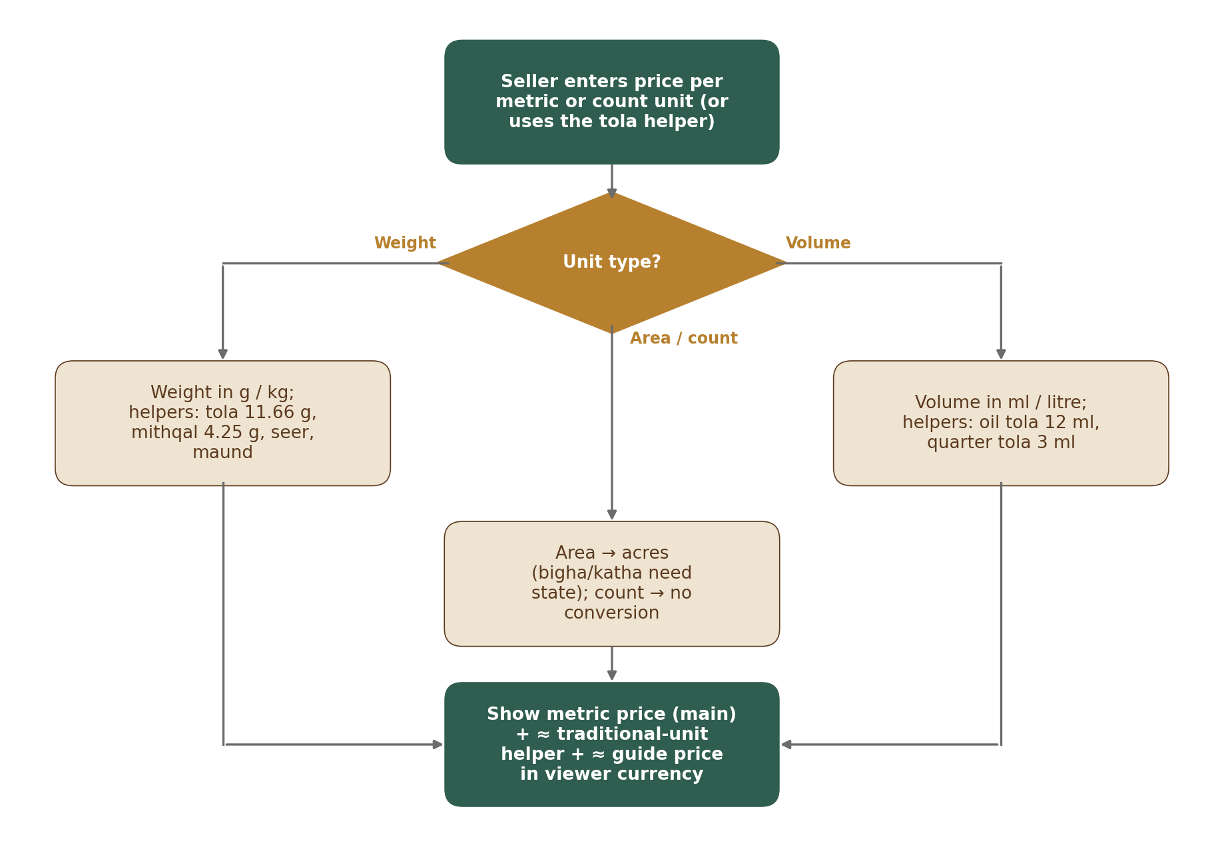
Figure 1 — How a listing unit is converted for display
Type | Unit | Standard unit | Factor (default)
Weight | gram / kg / quintal / tonne | gram | 1 / 1,000 / 1,00,000 / 10,00,000
Weight | tola (wood, chips, powder) | gram | 11.66
Weight | mithqal | gram | 4.25
Weight | seer / maund | gram | 933 / 37,320 (maund = 40 × 933 g)
Volume | ml / litre | ml | 1 / 1,000
Volume | tola (oil) | ml | 12
Volume | quarter tola (oil) | ml | 3
Count | piece, stick, packet, box, bottle, plant, tree | — | No conversion
Area | acre / hectare / m² | m² | 4,046.86 / 10,000 / 1
Area | bigha, katha, lessa | m² | Per state (state land-unit table, UNT-009)

ID | Requirement | Priority | Release
M01-FR-UNT-001 | The unit list and every factor are data managed by Admin on the units screen (M01-6 Section 12.13, in the Configuration Console shell, M16); changes are versioned and logged. | Must | R1
M01-FR-UNT-002 | Tola has two meanings: weight (11.66 g) for wood, chips and powder; volume (12 ml) for oil. The item’s type decides which is used. | Must | R1
M01-FR-UNT-003 | Bigha, katha and lessa require the seller to choose the state; the area is also shown in acres. If no factor exists for that state, the unit cannot be chosen. | Must | R1
M01-FR-UNT-004 | Prices are entered and shown per standard metric unit (g, kg, quintal, tonne, ml, litre) or per count unit (piece, packet…). Tola, mithqal, seer and maund are shown only as a smaller helper line, e.g. “≈ ₹6,000 per tola” (Legal Metrology Act 2009, Section 11 — counsel to confirm). Listing prices are never converted between currencies (guide price: CTY-006). | Must | R1
M01-FR-UNT-005 | Oil volume and weight are never converted into each other (ml ↔ g). | Must | R1
M01-FR-UNT-006 | Conversions are calculated with enough precision and shown rounded (≈ sign) to 2 decimals for money and 2 significant decimals for quantities. | Must | R1
M01-FR-UNT-007 | The listing form has a price helper: the seller may type a price per tola (or other traditional unit) and the form fills in the metric price. Only the metric price is stored. | Must | R1
M01-FR-UNT-008 | Which helper units are shown is set per category and per viewer country (e.g. tola for India and the Gulf, mithqal for the Gulf); configurable. | Must | R1
M01-FR-UNT-009 | State land-unit table: bigha, katha and lessa have a factor per state. Starting values (configurable): Assam — 1 bigha = 14,400 sq ft (1,337.8 m²), 1 katha = 2,880 sq ft (267.56 m²), 1 lessa = 144 sq ft (13.378 m²); West Bengal — 1 bigha = 14,400 sq ft (1,337.8 m²), 1 katha = 720 sq ft (66.89 m²). Admin adds other states only after checking that state’s land records, and records which record was checked. Changes use the common settings pattern (M01-6 Section 12.1). Screen: M01-6 Section 12.13. | Must | R1

5. Languages & Formats (LOC)
ID | Requirement | Priority | Release
M01-FR-LOC-001 | All user-facing text comes from a translation store with keys; English at launch; missing translations fall back to English. | Must | R1
M01-FR-LOC-002 | Layouts support right-to-left languages (Arabic) without redesign; tested with a sample RTL language before R2. | Must | R1
M01-FR-LOC-003 | Numbers: Indian grouping (1,00,000) for India-based users; international grouping (100,000) for others; the user can switch in settings. | Must | R1
M01-FR-LOC-004 | Large amounts in words: lakh / crore for Indian style (₹1.5 lakh, ₹2 crore); K / M for international style (₹150K, $2M). | Must | R1
M01-FR-LOC-005 | Dates shown as “24 Sep 2026” for everyone; times in the user’s time zone with the zone shown where it matters (e.g. deadlines). | Must | R1
M01-FR-LOC-006 | Service-target timers (e.g. 24 business hours) are calculated in IST business hours (Mon–Sat 09:00–19:00), skipping holidays in the holiday calendar (LOC-012). Legal timers (complaints, lawful orders) count calendar hours, not business hours. | Must | R1
M01-FR-LOC-007 | Currency is always shown with its symbol or ISO code (₹, $, AED …); amounts are always stored with their currency code. | Must | R1
M01-FR-LOC-008 | Language order after English: Arabic; then Hindi, Assamese and Bengali; then Chinese and Japanese. Fonts and layouts support Arabic, Devanagari, Bengali-Assamese and Chinese / Japanese scripts. | Must | R1
M01-FR-LOC-009 | Phone numbers are stored in international format (+ country code) and checked with a standard phone-number library for every country. | Must | R1
M01-FR-LOC-010 | Names are stored as entered in any script (no first-name / last-name assumption); addresses follow the layout of the country from the Country table. | Must | R1
M01-FR-LOC-011 | A shared trade-term word list links names used across languages and markets (e.g. agarwood, oud, agar, aloeswood, gaharu, jinko, chen xiang, xasi / sanchi, bakhoor, and grade names such as Double Super). Filled by M04; used by M07 search. | Should | R1
M01-FR-LOC-012 | Holiday calendar: the IST business-hours calculator skips holidays from a calendar managed in Admin (business_holidays table). | Must | R1
M01-FR-LOC-013 | Holiday calendar screen: staff see a year view per country, add or retire a holiday, or import a whole year from a file (the file is refused whole if any row is wrong). Before approval the preview shows how many open service-target timers would change their due time, with an example. Screen: M01-6 Section 12.6. | Must | R1

6. Page Addresses & SEO (URL)
Page | Address pattern
Listing | oudhtrade.com/listing/<title-words>-<listing-number>
Storefront | oudhtrade.com/store/<store-name>
Category / sub-category | oudhtrade.com/<category>/<sub-category>
Guide | oudhtrade.com/guides/<topic>
Other languages (later) | oudhtrade.com/<language>/… (e.g. /ar/, /hi/)

ID | Requirement | Priority | Release
M01-FR-URL-001 | Listing addresses end with the listing number; if the title changes, the old address redirects permanently to the new one. | Must | R1
M01-FR-URL-002 | Store names are chosen by the seller: 3–40 characters, letters, numbers and hyphens, unique, checked against banned words and protected brand names. | Must | R1
M01-FR-URL-003 | A store (trading) name can be changed once per 90 days (configurable; rule owned by M03); the old address redirects permanently and the storefront shows “Formerly {old name}” for 90 days (M03). | Must | R1
M01-FR-URL-004 | One site for all countries; no country sub-sites. | Must | R1
M01-FR-URL-005 | Sitemaps list public listings, storefronts, categories and guides; updated daily. | Must | R1
M01-FR-URL-006 | Opportunity pages, private pages, dashboards and test sites are marked “do not index” and excluded from sitemaps. | Must | R1
M01-FR-URL-007 | Public pages include page titles, descriptions, share previews (for WhatsApp and social media) and structured product data. | Should | R1
M01-FR-URL-008 | Reserved names: store names and page addresses cannot use reserved, banned or protected brand names from the reserved_names list, which Admin manages. | Must | R1
M01-FR-URL-009 | Reserved-name check on existing names: when staff add a name to the reserved_names list, the screen lists the existing store names and page addresses that match it before the change is sent for approval. Existing stores are not renamed automatically; the matches go to moderation (M12). Screen: M01-6 Section 12.5. | Must | R1

7. Audit Log (AUD)
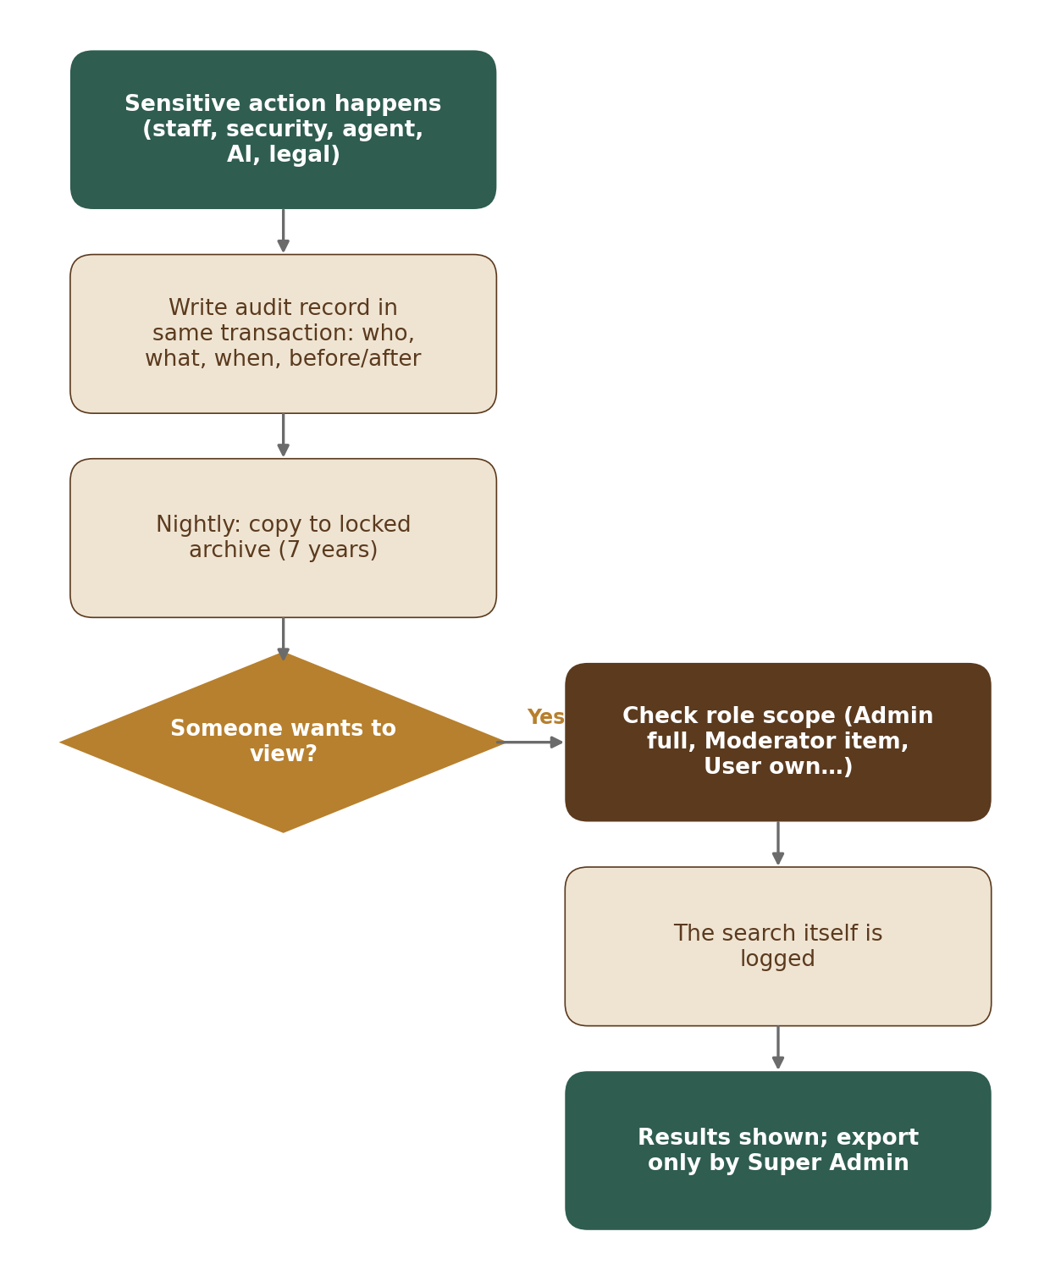
Figure 2 — Audit log write and access
ID | Requirement | Priority | Release
M01-FR-AUD-001 | Recorded actions: staff decisions (approve, reject, ban, refund, config change), security events, field-agent actions, AI flags and suggestions, legal orders, private-document views, data exports. | Must | R1
M01-FR-AUD-002 | Each record holds: time, actor (and role), action, target, reason, before and after values, IP / device, and a link to the previous record so tampering can be detected. | Must | R1
M01-FR-AUD-003 | Records are written in the same transaction as the action; nobody (including Super Admin) can edit or delete them. | Must | R1
M01-FR-AUD-004 | Records are kept 7 years; older records are copied nightly to a locked archive. | Must | R1
M01-FR-AUD-005 | Viewing: Super Admin and Admin search all; Moderator sees history of the item or account under review; Finance sees payment, refund and invoice records; Support sees an account summary without private documents; users see their own account activity; field agents see their own actions. | Must | R1
M01-FR-AUD-006 | Every search of the audit log is itself recorded. | Must | R1
M01-FR-AUD-007 | Only Super Admin can export audit records (e.g. for police or legal cases); the export is recorded. | Must | R1
M01-FR-AUD-008 | Audit log viewer: staff search by time, actor, action and target within their role (AUD-005). A record’s detail shows before and after values and the result of the chain check (whether the record’s link to the previous record is intact). The viewer has no edit or delete action; export needs a reason. Screen: M01-6 Section 12.9. | Must | R1

8. Configuration & Feature Switches (CFG)
ID | Requirement | Priority | Release
M01-FR-CFG-001 | Modules read settings through one configuration interface; values are cached and refreshed within 60 seconds of a new version being published. | Must | R1
M01-FR-CFG-002 | Every setting has a safe default in code so the platform runs if configuration is missing. | Must | R1
M01-FR-CFG-003 | Feature switches can target a release, an environment, a role or a list of test accounts. | Must | R1
M01-FR-CFG-004 | Any setting can have overrides by account list, role, plan, category or country; every override is logged. The precedence order is in CFG-005. | Must | R1
M01-FR-CFG-005 | Settings precedence: account list → role → plan → category → country → global. The most specific value wins. | Must | R1
M01-FR-CFG-006 | Publish and approval: settings are published only through ConfigService.publish, called by the Configuration Console (M16) after approval. The settings screens are in M01-6 Section 12; approved settings can also move from staging by export / import (ENV-008), using the same publish step and approval. Every change needs a second person who is not the editor, at two levels: a high-impact change needs a Super Admin; any other change needs any other Admin. The list of high-impact settings and the approval rule are in M01-6 Section 12.1 (the one source). Every publish and rollback is versioned and audited, and Module 1 then emits config.published. | Must | R1
M01-FR-CFG-007 | Edit conflicts: records edited by staff carry a row version (row_version); a save on a record that someone else changed is refused with a clear message (“Changed by someone else — please reload”). | Must | R1
M01-FR-CFG-008 | Preview impact: before a draft is sent for approval, the system shows what changes (each old value → new value, with its scope), who is affected (counts of accounts, listings, countries or open timers, where they can be worked out) and one worked example. The approver sees the same preview, refreshed. Pattern: M01-6 Section 12.1. | Must | R1
M01-FR-CFG-009 | Scheduled publish, history and rollback: an approved change is published at once or at a chosen date and time, and a scheduled change can be cancelled until it runs. Every version keeps who made it, who approved it, when it was published and why; a reason is required for every draft sent, approval, rejection, cancel and rollback. Staff can roll back to any earlier version; the rollback is a new draft that goes through the same approval (M01-6 Section 12.1). | Must | R1

9. Events, Jobs & Scheduler (EVT)
ID | Requirement | Priority | Release
M01-FR-EVT-001 | Events are written to the outbox in the same transaction as the change and delivered at least once; handlers must be safe to run twice. | Must | R1
M01-FR-EVT-002 | Background jobs retry with increasing delay; after the last retry they move to a failed list that staff can review and re-run. | Must | R1
M01-FR-EVT-003 | The scheduler runs timed tasks (expiry, reminders, trust updates, retention, sitemaps, quarterly user notice) and records each run. | Must | R1
M01-FR-EVT-004 | Alerts fire when the outbox or job backlog is older than 5 minutes (configurable). | Must | R1
M01-FR-EVT-005 | Failed jobs screen: staff see jobs that are still retrying and jobs in the dead-letter list (all retries used), with the last error. They can retry one job or up to 100 jobs of one kind, or discard a dead job with a reason. Every retry and discard is written to the audit log. Screen: M01-6 Section 12.11. | Must | R1

10. Data Retention & Legal Hold (RET)
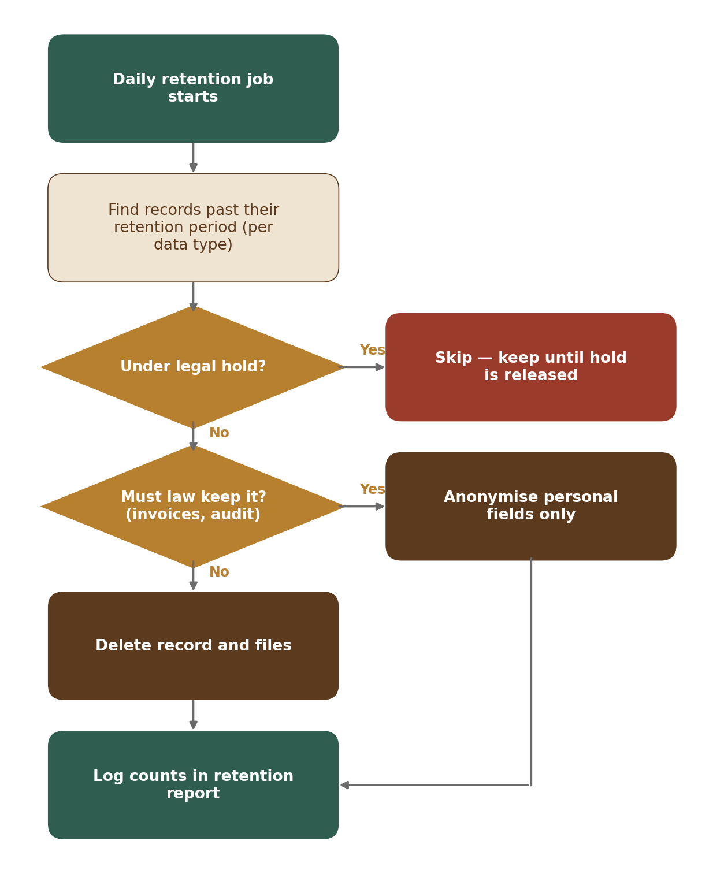
Figure 3 — Daily retention job
ID | Requirement | Priority | Release
M01-FR-RET-001 | A retention period is set per data type (e.g. unused uploads 7 days, closed accounts 30 days then anonymised, chat after account closure per counsel, invoices 8 years, audit log 7 years, security logs ≥ 180 days, processing logs ≥ 1 year) [TBC: final periods with counsel]. | Must | R1
M01-FR-RET-002 | A daily job deletes or anonymises data past its period, keeps what the law requires, and writes a report. | Must | R1
M01-FR-RET-003 | Legal hold (set by Admin for a legal order or dispute) stops deletion of all linked data until released; setting and releasing a hold is logged. | Must | R1
M01-FR-RET-004 | Legal hold screen: staff see all holds (active and released) with scope, reason, reference and who placed them. Placing and releasing a hold both need a reason. Before a release, the screen shows what the next daily retention run would then delete or anonymise. Screen: M01-6 Section 12.10. | Must | R1
M01-FR-RET-005 | Retention policies screen: each data type shows its period, action (delete or anonymise), legal basis and the holds that affect it. Period changes are high-impact settings and use the common settings pattern (M01-6 Section 12.1). A period can never be set shorter than the legal minimum stored for that data type. Screen: M01-6 Section 12.12. | Must | R1

11. Cookie Consent (CKE)
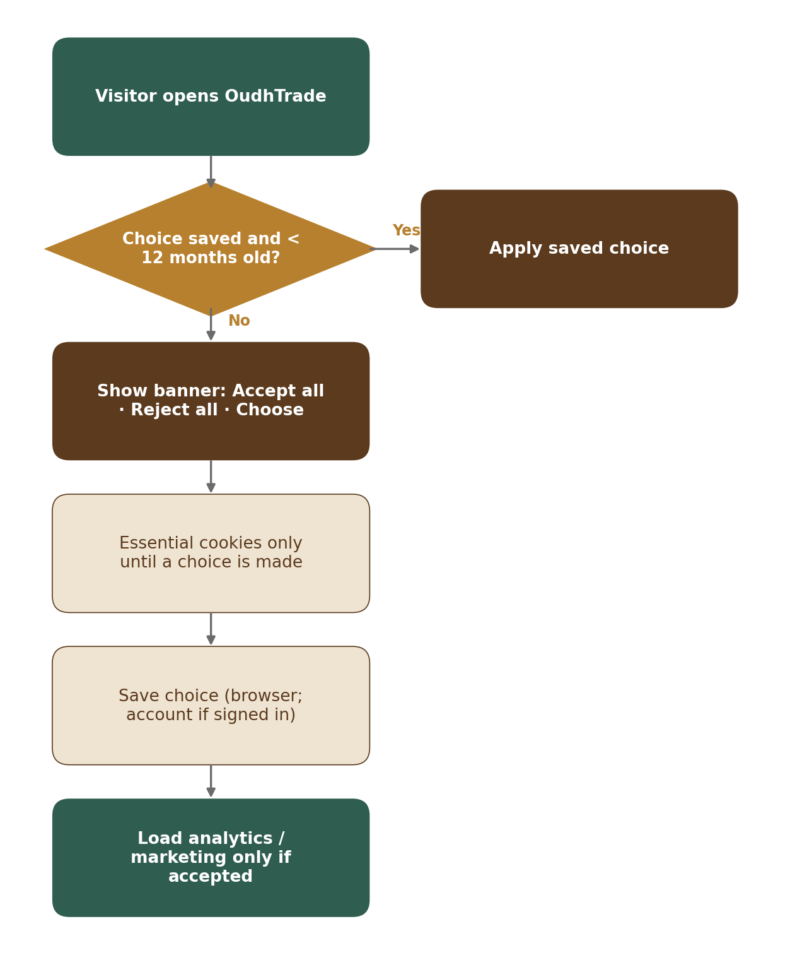
Figure 4 — Cookie consent flow
ID | Requirement | Priority | Release
M01-FR-CKE-001 | Essential cookies are always on; analytics and marketing cookies and tags load only after consent. | Must | R1
M01-FR-CKE-002 | Banner buttons “Accept all”, “Reject all” and “Choose” have equal size and prominence; no pre-ticked boxes. | Must | R1
M01-FR-CKE-003 | The same banner and rules apply to all countries. | Must | R1
M01-FR-CKE-004 | A “Cookie settings” footer link lets visitors change their choice at any time. | Must | R1
M01-FR-CKE-005 | The choice is remembered for 12 months, then asked again; for signed-in users it is saved to the account and applied on web and apps. | Must | R1
M01-FR-CKE-006 | Consent records (choice, time, banner version) are stored as proof. | Must | R1
M01-FR-CKE-007 | Cookie-free KPI counts: key counts (page views, listing views, enquiries, sign-ups) are counted on the server without cookies or personal identifiers. | Must | R1

12. API Conventions & Errors (API)
ID | Requirement | Priority | Release
M01-FR-API-001 | All APIs are versioned (/v1) and described in an OpenAPI contract shared by web, apps and admin. | Must | R1
M01-FR-API-002 | Errors use one format with a code, a user-friendly message (translated) and a request ID for support. | Must | R1
M01-FR-API-003 | Lists are paginated; requests are rate-limited per user and IP with a clear “please try again later” message. | Must | R1
M01-FR-API-004 | Friendly error pages: page not found (404), something went wrong (500) and planned maintenance, each with a search box and help link. | Must | R1
M01-FR-API-005 | Idempotency keys: writes that create records or charge money accept an Idempotency-Key header. The first response is stored for 24 hours (idempotency_keys table) and returned again for repeats, so a retried request never creates a second record or charge. | Must | R1
M01-FR-API-006 | Rate-limit headers: responses carry RateLimit-Limit, RateLimit-Remaining and RateLimit-Reset; a refused request gets HTTP 429 with Retry-After. | Must | R1
M01-FR-API-007 | Pagination: lists use cursor paging; 20 items by default, at most 100; the response gives the next cursor. | Must | R1
M01-FR-API-008 | Deprecation: an old API version is supported for at least 6 months after its replacement; responses carry Deprecation and Sunset headers; the change is announced in release notes. | Must | R1

13. Monitoring (OBS)
ID | Requirement | Priority | Release
M01-FR-OBS-001 | Every request carries a request ID visible in logs and error messages. | Must | R1
M01-FR-OBS-002 | Dashboards and alerts for availability, error rate, response time, job backlog, file-processing failures and security events. | Must | R1
M01-FR-OBS-003 | Security logs are kept in India for at least 180 days (CERT-In). | Must | R1
M01-FR-OBS-004 | Automatic speed checks every 5 minutes from Mumbai, Dubai and Singapore; target: main pages usable ≤ 2.5 s in India and ≤ 3 s elsewhere. | Must | R1
M01-FR-OBS-005 | Monthly cloud budget USD 1,500 (starting value, configurable) with alerts at 80 % and 100 % to the founder and tech lead, a cost-per-service report and alerts for unusual spending. | Must | R1
M01-FR-OBS-006 | A public status page (status.oudhtrade.com), hosted separately from the main platform, shows service status, incidents and planned maintenance; error pages link to it. | Must | R1
M01-FR-OBS-007 | Personal-data processing logs are kept for at least 1 year in a locked log archive in India. | Must | R1
M01-FR-OBS-008 | Application logs are searchable for 30 days and archived for 1 year, in India. | Must | R1

14. Country & Currency Reference (CTY)
ID | Requirement | Priority | Release
M01-FR-CTY-001 | One Country table for all modules: ISO country code, name (translated), phone code, currency, guide currency, default language, number style, time zones, weekend days, address layout, status and allowed features. Managed in the Country table screen (M01-6 Section 12.4); versioned and logged. | Must | R1
M01-FR-CTY-002 | States and regions (full ISO 3166-2 codes, e.g. IN-AS) for India and other countries where needed, and India districts (LGD codes); used by addresses, listings, profiles, lots, bigha / katha factors and documents per state. | Must | R1
M01-FR-CTY-003 | Country status: allowed, restricted (listed features switched off) or blocked (sanctioned; list set with counsel). Blocked status is used at the edge (SEC-004) and at sign-up (M02). | Must | R1
M01-FR-CTY-004 | Country feature rules (e.g. Opportunities visible, export listings visible) are read by modules through one interface. | Must | R1
M01-FR-CTY-005 | Exchange rates for the guide currencies are fetched daily from an approved provider [TBC: provider] and stored with date and source. If fetching fails, the last rates are used; an alert fires after 24 hours, and after 48 hours the guide price is hidden. | Must | R1
M01-FR-CTY-006 | Guide price: under a listing price, the price is also shown in the viewer’s guide currency, e.g. “≈ AED 270 (guide only)”. It is never used for sorting, filtering, billing or quotations. The viewer can change the guide currency or switch it off. | Must | R1
M01-FR-CTY-007 | Guide currencies (configurable): AED, SAR, QAR, KWD, OMR, BHD, SGD, MYR, IDR, THB, VND, HKD, TWD, CNY, JPY, KRW, EUR, GBP, plus INR and USD. | Must | R1
M01-FR-CTY-008 | The Country table holds the OTP channel order, allowed sign-in methods, SMS sender-name status and daily OTP cost cap per country (used by M02). Channel values: sms, whatsapp, email and voice (voice-call codes). Examples: India {sms, voice, whatsapp, email} — SMS, then voice-call codes (e.g. for farmers), then WhatsApp, then email; most other countries WhatsApp, then SMS, then email; China SMS then email, with Google sign-in not allowed. Daily OTP cost cap per country (starting values, configurable): India INR 3,000 a day; every other country USD 50 a day each; an alert fires at 80 % of the cap. Changes take effect without a code release. | Must | R1

15. Rate Limits (RTL)
ID | Requirement | Priority | Release
M01-FR-RTL-001 | One shared rate-limit service is used by every module. A limit is defined by who (visitor IP / device, account, plan), what (action group) and time window. | Must | R1
M01-FR-RTL-002 | Limits are settings with safe defaults (M01-3 Section 10) and can be overridden by plan, role and country. | Must | R1
M01-FR-RTL-003 | When a limit is reached the user gets a friendly, translated message with the waiting time, e.g. “You’re doing this too often. Please try again in 2 minutes.” (HTTP 429 with Retry-After). | Must | R1
M01-FR-RTL-004 | Staff, approved partner API keys and genuine search-engine crawlers (checked by reverse DNS) have their own limits. | Must | R1
M01-FR-RTL-005 | Repeated breaches lead to a temporary block (default 15 minutes) and a security event; permanent blocks are set only by staff. | Must | R1
M01-FR-RTL-006 | Each module lists its own limits in its document 3 and registers them with the service. | Must | R1
M01-FR-RTL-007 | If the rate-limit store is unavailable, browsing continues with per-server limits, but sensitive actions (uploads, sign-in, OTP, contact reveal) are refused until it is back. | Must | R1

16. Edge & Application Security (SEC)
ID | Requirement | Priority | Release
M01-FR-SEC-001 | A web application firewall in front of the site with managed rules for common attacks, known bad inputs and IP reputation; all blocks are logged. | Must | R1
M01-FR-SEC-002 | Bot protection and anti-scraping: bot detection, page-view limits per visitor on listing and store pages, a challenge for suspicious traffic; genuine search engines (checked by reverse DNS) allowed. | Must | R1
M01-FR-SEC-003 | Seller contact details are never included in public page code or sitemaps; they are revealed only through the owning module’s rate-limited, logged API. | Must | R1
M01-FR-SEC-004 | Visitors from blocked (sanctioned) countries are stopped at the edge with a clear page, using the Country table. | Must | R1
M01-FR-SEC-005 | HTTPS only (HSTS), TLS 1.2 or higher; security headers (content security policy, frame protection, content-type, referrer and permissions policies); cookies Secure, HttpOnly and SameSite; cross-site requests only from OudhTrade domains; protection against cross-site request forgery on forms. | Must | R1
M01-FR-SEC-006 | Data encrypted at rest with managed keys rotated yearly; secrets kept in a secrets manager and rotated automatically every 90 days where supported; no secrets in code or logs. | Must | R1
M01-FR-SEC-007 | All server clocks are synced to NIC / NPL time servers or sources traceable to them (CERT-In) [TBC: counsel to confirm source]. | Must | R1
M01-FR-SEC-008 | Cyber incidents of the types listed by CERT-In are reported within 6 hours, using an incident runbook and a named point of contact. | Must | R1
M01-FR-SEC-009 | Standard protection against denial-of-service attacks, with a stricter “under attack” mode that can be switched on by a feature switch. | Must | R1
M01-FR-SEC-010 | Security contact: a “Report a security issue” page and /.well-known/security.txt are live from R1 (text by M17, publishing by Module 1). | Must | R1
M01-FR-SEC-011 | Upload size is enforced at storage: each upload link carries the size limit for its purpose (pre-signed POST with content-length-range); uploads that are never confirmed are deleted after 24 hours. | Must | R1

17. AI Gateway (AIG)
Module 1 owns the AI gateway (tables ai_requests and ai_budgets in the platform schema). The AI features themselves belong to other modules (M05, M07, M09, M12, M17); search embeddings are stored in the M07 schema.
ID | Requirement | Priority | Release
M01-FR-AIG-001 | All AI calls from any module go through the AI gateway; the provider and model can be switched in configuration without code changes. | Must | R1
M01-FR-AIG-002 | Data rule: Restricted data (ID and document numbers, verification documents, photo location, passwords, keys, audit log) and contact details are blocked before sending. One exception (PRD-AI-006): the text of a foreign-language verification document may be sent for translation for the reviewer only after ID and document numbers are removed; images of IDs and selfies are never sent. Other personal data is sent only when the purpose allows it, and minimised. The provider must be listed in the cross-border register; an India-hosted model is preferred. | Must | R1
M01-FR-AIG-003 | Every AI call is logged in ai_requests: module, purpose, provider, model, tokens, cost, data level sent and result. | Must | R1
M01-FR-AIG-004 | Monthly cost budgets per module and purpose (ai_budgets) with alerts at 80% and 100%; at 100% non-essential AI features pause. Starting values (configurable): USD 300 a month in total, split by purpose — moderation 40 % (USD 120), translation 30 % (USD 90), search 20 % (USD 60), other 10 % (USD 30). | Must | R1
M01-FR-AIG-005 | AI output shown to users is labelled. AI never approves, bans, verifies or changes trust by itself (PRD-GEN-009). | Must | R1
M01-FR-AIG-006 | AI usage and budgets screen: per module and purpose, staff see calls, tokens and cost this month against the budget, the alert state (80 % or 100 %) and whether the purpose is paused. Budget changes are high-impact settings and use the common settings pattern; a paused purpose starts again when a raised budget is published or the next month starts. Screen: M01-6 Section 12.8. | Must | R1

